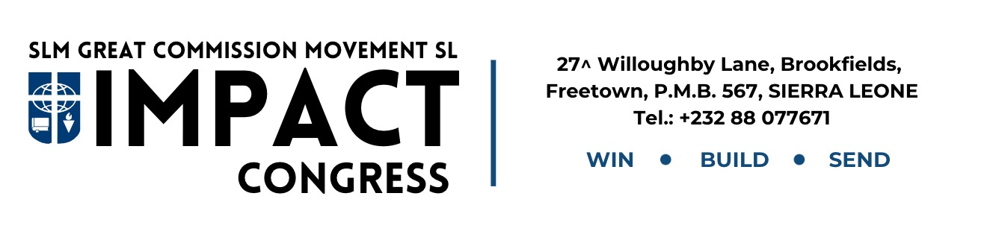

1st July,2025

Dear Sir/ Madam,

**Letter Of Financial Assistance Greetings**

I hope this letter finds you in good health and high spirits. I am writing to request your kind support for Impact 2025, a national congress that brings together students and professionals for a week of teaching, training, and fellowship.

This year’s event is scheduled to take place from **14th to 21st September 2025** at **Mount Zion Training Centre, Mothaim Community, Freetown, Sierra Leone**. The goal of Impact 2025 is to equip and empower students to make a meaningful impact on their campuses and in their communities through leadership, service, and spiritual growth.

We are reaching out to individuals like you who believe in the power of youth development and national transformation. A contribution of **Two Thousand leones** (**Nle2,000)** will go a long way in helping us cover training materials, logistics, and participant support.

Your assistance would be deeply appreciated and would make a real difference in the lives of the future leaders of our nation.

Thank you for considering this request. Please feel free to contact me if you need more information. We would be honored to have you partner with us in this vision.

Yours sincerely,

Jim Marouf Kamara.

(On behalf of the Impact 2025 Planning Team)